savarjiSo 6F: wyaldidobis riskis Sefaseba
mosalodneli dro: 3 saaTi
monacemebi: monacemebi qvedireqtoriidan Riskcity exercises/exercise06F/data
miznebi: am savarjiSoSi vnaxavT, wyaldidobis riskis SefasebaSi rogor gavakeToT wyaldidobis siRrmis Sesaxeb (vTqvaT, wyaldidobis modelidan miRebuli) informaciis kombinireba Senobebis Sesaxeb monacemebTan, rogoricaa monacemebi adgilmdebareobis, simaRlisa da saSeni masalebis Sesaxeb. SevafasebT risks wyaldidobis ganmeorebis sxvadasxva periodis (10, 50 da 100 weli) mqone sami scenarisTvis. savarjiSos bolos unda SegeZloT am proceduris nabijebis gageba da gameoreba.

riskqalaqma zaralis gamomwvevi ramdenime Zlieri wyaldidobis SemTxveva ganicada. wyaldidobis riskis Sesafaseblad hidravlikuri modelrebiT Seiqmna wyaldidobis siRrmis rukebi ganmeorebis sxvadasxva periodisTvis. SezRuduli drois gamo, Cven wyaldidobis mxolod sam scenars ganvixilavT, ganmeorebis 10-, 50- da 100-wliani periodebiT.

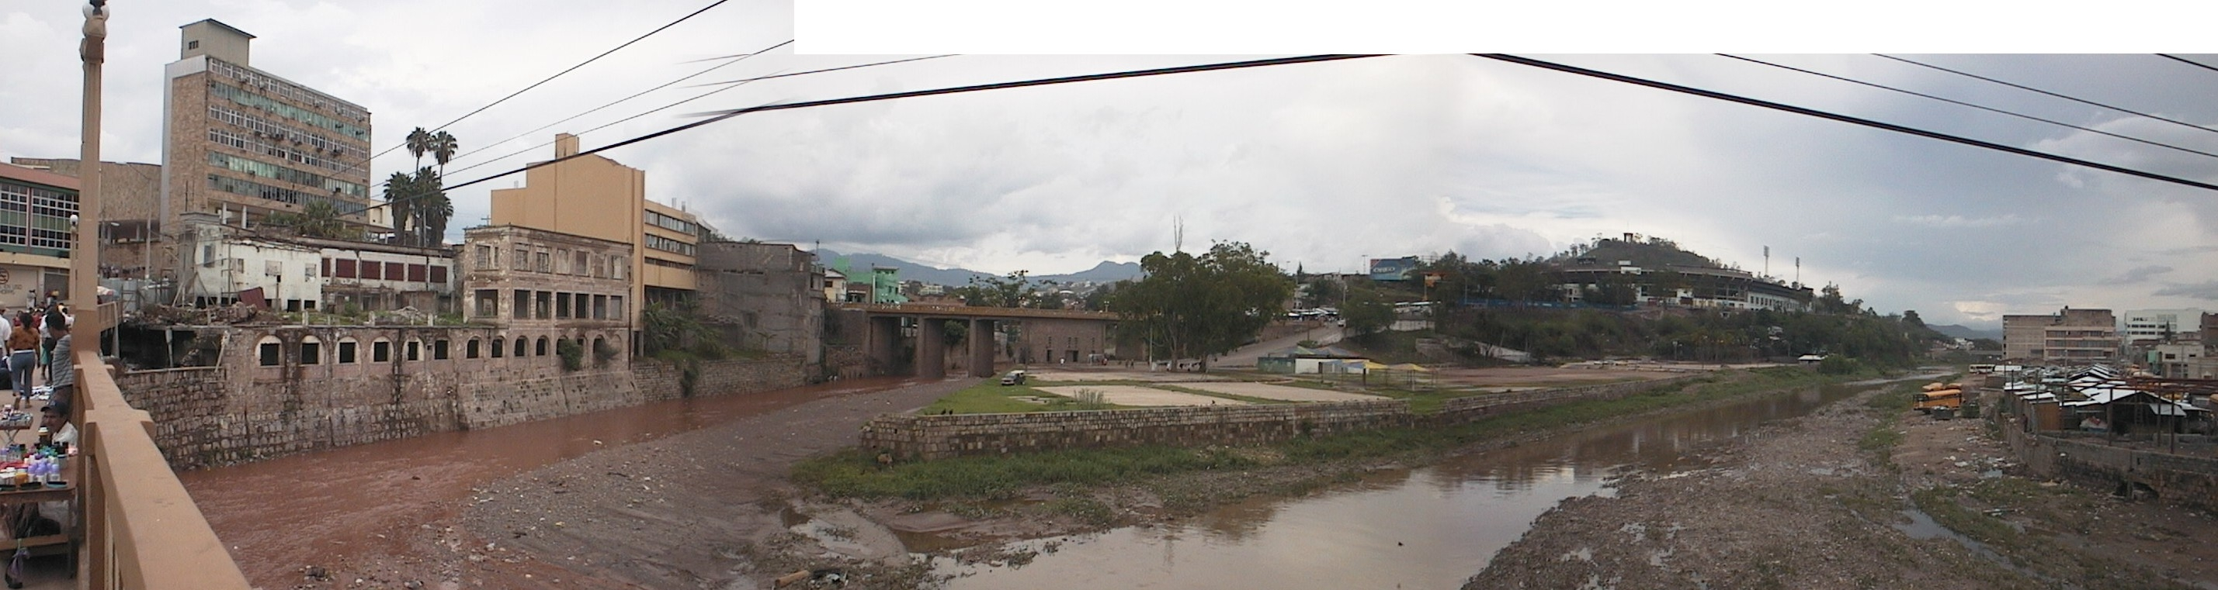
suraTi: Senobebi ori mdinaris SesarTavTan riskqalaqSi

saxeli | tipi | mniSvneloba
monacemebi wyaldidobis Sesaxeb
Flood_100y,  Flood_50y,  Flood_10y | rastruli ruka | wyaldidobis siRrmis rukebi, miRebuli wyaldidobis modelirebis kvlevidan scenarebisTvis ganmeorebis 100, 50 da 10-wliani periodebiT.
monacemebi Senobebis Sesaxeb
Building_map_1998 | rastruli ruka | Senobebis ganaxlebuli ruka 1998 wlis katastrofis Semdeg arsebuli situaciisTvis. yvela SenobisTvis arsebobs informacia urbanuli miwaTsargeblobis tipis, sarTulebis raodenobis, Senobis farTobisa da sarTulebis jamuri farTis Sesaxeb.

nawili 1
am savarjiSoSi viyenebT riskis raodenobrivi Sefasebis midgomas, romelSic riskis kvantificireba xdeba riskis im gansazRvrebis Sesabamisad, romelic mocemulia saxelmZRvanelos 1 TavSi. rogorc iq aris axsnili, am gantolebis bazisuri formaa:

riski = safrTxe * mowyvladoba * riskis qveS myofi elementebis raodenoba

es gantoleba ar aris mxolod konceptualuri xasiaTis; SesaZlebelia mis mixedviT realuri gamoTvlebis ganxorcieleba gis-Si arsebuli sivrculi monacemebis safuZvelze safrTxeebis riskis raodenobrivi SefasebisTvis. is, Tu ra saxiTaa daxasiaTebuli riskis qveS myofi elementebis raodenoba (magaliTad, rogorc Senobebis raodenoba, rogorc adamianebis raodenoba, rogorc ekonomikuri Rirebuleba, Tu rogorc mniSvnelobis mqone Tvisebrivi kategoriebis farTobi), gansazRvravs agreTve imas, Tu ra saxiT iqneba warmodgenili riski. gantolebaSi safrTxis komponenti realurad aRniSnavs safrTxis Semcveli movlenis mocemul periodSi mocemuli intensivobiT ganxorcielebis albaTobas (magaliTad, wliuri albaToba). 1 gantolebis gamoyenebiT riskis raodenobrivad gamosaTvlelad mowyvladoba SemosazRvrulia gaTvaliswinebuli riskis qveS myofi elementebis fizikuri mowyvladobiT, gansazRvrulia safrTxis Semcveli movlenis intensivobiTa da riskis qveS myofi elementebis TaviseburebebiT (magaliTad, Senobis tipi). SesaZlebelia gantolebis Semdegi saxiT modificireba:

R_{S} = P_{T} * P_{L} * V * A

sadac:
P_{T} aris mocemul adgilze ganmeorebis mocemuli periodis mqone specifikuri safrTxis ganxorcielebis droiTi (magaliTad, wliuri) albaToba;
P_{L} aris lokaciuri anu sivrciTi albaToba imisa, rom mocemul adgilze ganmeorebis mocemuli periodis mqone specifikuri safrTxe ganxorcieldeba da zemoqmedebas moaxdens riskis qveS myof elementebze;
V aris fizikuri miwyvladoba, romelic ganisazRvreba, rogorc safrTxis scenaris ganxorcielebis Sedegad riskis qveS myofi specifikuri elementis dazianebis xarisxi safrTxis mocemuli lokaluri intensivobisTvis;
A aris riskis qveS myofi im specifkuri tipis elementis kvantifikacia, romelsac vafasebT.

aq mniSvnelovania mivuTiToT, rom sididis kvantificireba sxvadasxva gziT SeiZleba da rom riski kvantificirebulia imave gziT, ra gziTac sididea kvantificirebuli. magaliTad, sidide SeiZleba mocemuli iyos ricxvebiT, rogoricaa Senobebis raodenoba (maSin riski aris im Senobebis raodenoba, romlebic SeiZleba daziandes), adamianebis raodenoba (magaliTad, dazianebebi/msxverpli/dazaralebuli), milebis dazianebebis raodenoba qselis erT kilometrze da sxva. riskis qveS myofi elementebis kvantificireba aseve SeiZleba ekonomikuri TvalsazrisiT. maSin is Cveulebriv gamosaxeba, rogorc zarali.
raTa am komponentebis Sefaseba SegveZlos, unda gvqondes sivrculi informacia, radgan yvela komponenti cvalebadobs rogorc sivrceSi, ise droSi. safrTxis scenaris ganxorcielebis droiT albaTobas (P_{T}) aseve aqvs sivrculi komponentic. magaliTad, ganmeorebis mocemuli periodis mqone wyaldidobas aqvs garkveuli moculoba da misi intensivoba sivrceSi cvalebadobs. termini P_{L} aCvenebs ganxorcielebisa da zemoqmedebis sivrcul albaTobas. is ar aris yvela tipis safrTxisTvis relevanturi da bevr SemTxvevaSi es albaToba SeiZleba miTiTebuli iyos, rogorc 1, Tuki mocemulia safrTxis specifikuri scenari (magaliTad, adgili, romelic daitboreba, Tu mocemulia ganmeorebis 50-wliani periodi).

- gaxseniT rastruli ruka Flood_100y da daamateT rastruli ruka building_map_1998. mieciT am ukanasknel rukas 50-%-ani gamWvirvaloba. gaxseniT Pixel-Information fanjara da SeiswavleT datborili adgilebi da wylis siRrme am adgilebze.
- daxureT rukis fanjara.

rogorc xedavT, qalaqis centris didi nawilebi datborilia, magram ufro CrdiloeTiTac naxavT wyliT dazianebul Senobebs. zogierT adgilas wylis siRrme SeiZleba 8 metrs aRwevdes!

- momdevnio savarjiSoSi gavaanalizebT, ramdeni Senoba dazianda wyaldidobis sam scenarSi.
- SeqmeniT wyaldidobis gavrcelebis ruka. amisTvis akrifeT:
floodextent_010:=ifundef(flood_10y,0,1)
SekiTxva 6F1:
ras akeTebs es debuleba?

- SexedeT Sedegs.
- gadaafareT ruka Buildings_map_1998 rukiT Floodextent_010 da SeqmeniT gadaafarvis cxrili Building_flooded_010.
- gaxseniT gadaafarvis cxrili da daamateT saxlebis zedapiris farTobis sveti. es gaakeTeT svetis meniuSi SeerTebis operaciiT. zedapiris farTobis Sesaxeb informacia SegiZliaT naxoT histogramaSi Building_map_1998. daamateT sveti saxelad `farTobi~, magram saxelad daarqviT area_building.
SekiTxva 6F2:
ra ganasxvavebs am axlad damatebul svets ukve arsebuli svetisgan, saxelad “area”? maTi mniSvnelobebi yvela striqonisTvis gansxvavebulia?

- gamoTvaleT dazianebuli Senobebis farTobis pricentuli wili. akrifeT:
Perc_affected_010:= iff(floodexent_010=1,area/area_building,0)
- gamoTvaleT wyaldidobiT nawilobriv dazianebuli Senobebis raodenoba. amisaTvis akrifeT:
partially_flooded_010 := iff(perc_affected_010>0,1,0)
- da gamoTvaleT im Senobebis raodenoba, romlebic bolomde daitbora:
completely_flooded_010 = iff(perc_affected_010=1,1,0)
SekiTxva 6F3:
ramdeni saxlia axla bolomde datborili da ramdeni – nawilobriv? sul ramdeni Senobaa dazianebuli?

- gaimeoreT mTeli es procedura (am CarCos dasawyisidan) wyaldidobis danarCeni ori rukisTvis
- CawereT dazianebuli Senobebis raodenoba (sul) da SeitaneT isini riskis grafikSi. naxeT ori magaliTi qvemoT.
SekiTxva 6F4
rogor aris kvantificirebuli riski am SefasebaSi?

riskis mrudis warmodgenis ori xerxi. marcxniv: zarali ganmeorebis periodis mixedviT. marjvniv: zarali wliuri albaTobis mixedviT.

ekonomikuri zaralis gamoxatvis ramdenime gza arsebobs. albaTuri maqsimaluri zarali (amz – PML) aris udidesi zarali, romelic SesaZleblad miiCneva ganmeorebis gansazRvrul periodSi, rogoricaa 100 weliwadSi 1 an 250 weliwadSi 1. zemoT naCveneb grafikebze amz (PML) 1000 weliwadSi 1 ganmeorebisTvis aris 1400. riskis warmodgena aseve SeiZleba mrudis saxiTac, romelzec yvela scenari asaxulia Tavisi ganmeorebis periodiT an albaTobiT da masTan dakavSirebuli zaraliT. aseT riskis mruds aseve uwodeben zaralis eqsidansis mruds (zem - LEC) (eqsidansi (excedance) – raodenoba, romliTac mocemuli parametri aWarbebs standartul an dasaSveb sidides). marcxena grafiks is upiratesoba aqvs, rom masze ukeTesad Cans, ganmeorebis romel periodebs Seaqves yvelaze didi wvlili zaralSi. marjvena mrudis gamoyeneba SeiZleba pirdapir, saSualo wliuri zaralis (swz – AAL) gamosaTvlelad. es keTdeba grafikis qveS arsebuli farTobis gamoTvliT (ixileT agreTve saxelmZRvanelo, sesia 6.5.5).

axla Building_map_1998 cxrils davamatebT dazianebuli Senobebis procentul raodenobas, romelic gamovTvaleT.

- gaxseniT cxrili: Building_map_1998
- SeaerTeT am cxrilTan cxrilis Buildings_flooded_010 sveti Perc_affected_010.
- mihyeviT nabijebs SeerTebis (join) vizardSi. radgan cxrilSi Buildings_flooded_010 zogierTi SenobisTvis erTze meti Canaweria, unda aarCioT agregaciis funqcia.
- aarCieT MAXIMUM.

SekiTxva 6F5:
ratom aris cxrilSi Building_flooded_010 erTze meti Canaweri zogierTi SenobisTvis? ratom aris funqcia “Maximum” swori arCevani?

- gaimeoreT es procedura (am CarCos dasawyisidan) wyaldidobis danarCeni ori scenarisTvis (cxrils Building_map_1998 daamateT svetebi Perc_affected_050 da Perc_affected_100).

nawili 2
am savarjiSos momdevno nawilSi Cven gavakeTebT bmuls Senobis Tvisebebsa (riskis qveS myofi elementebis mowyvladoba) da safrTxis Taviseburebebs Soris (am SemTxvevaSi, wyaldidobis siRrmes) Soris. imisaTvis, rom SevZloT am bmulis gakeTeba, unda movamzadoT monacemebi. saWiroa wyaldidobis siRrmis rukebis klasificireba (ILWIS-is terminologiiT – daserili (sliced)) da Senobebis iseTnairad daxasiaTdeba, rom azri hqondes wyaldidobis riskisTvis. wyaldidobis warsuli SemTxvevebis gamocdilebis safuZvelze viciT, rom arsebobs Senobebis ori ZiriTadi maxasiaTebeli, romlebic mowyvladobas gansazRvravs. esenia: saSeni masala da sarTulebis raodenoba. Cven am ori parametris kombinaciis safuZvelze SevqmniT axal klass da gavakeTebT maT bmuls wyaldidobis siRrmis klasificirebul rukebTan.

vakeTebT wyaldidobis siRrmis sami rukis klasificirebas (flood_10y, flood_50y da flood_100y).

- SeqmeniT jgufis domeni Flooddepth (wyaldidobis siRrme) da CasviT Semdegi klasis sazRvrebi:

zeda zRvari | klasis saxeli | kodi
0.5 | < 0.5 m | 1
1 | 0.5 – 1.0 m | 2
3 | 1.0 – 3.0 m | 3
6 | 3.0 – 6.0 m | 4
99 | > 6 m | 5

- dasereT (dayaviT) wyaldidobis siRrmis sami ruka da daarqviT: flood_010_cla, flood_050_cla da flood_100_cla.

axla vamzadebT Senobebis maxasiaTeblebs. 1 nabijia domenis Seqmna saSeni masalebis sami ZiriTadi tipiT:

- SeqmeniT klasis domeni Building_mat da CasviT Semdegi sami klasi:

klasis saxeli | kodi
Tixatkepnili da xe | a
aguri | b
betoni | c

- daawkapuneT marjvena RilakiT domenze landuse (miwaTsargebloba) da aarCieT “create table” (Seqmeni cxrili). daarqviT mas Building_mat.
- gaxseniT cxrili Building_mat da daamateT sveti Building_mat da mieciT mas domeni Building_mat.
- SeavseT cxrili ise, rogorc naCvenebia qvemoT mocemul suraTze.

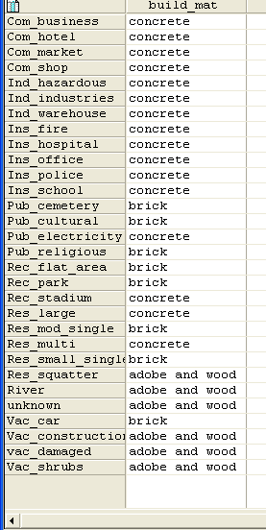
samS-mas
kom_biznesi betoni
kom_sastumro betoni
kom_bazari betoni
kom_maRazia betoni
ind_saSiSi betoni
ind_warmoeba betoni
ind_sawyobi betoni
ins_saxanZro betoni
ins_dawesebuleba betoni
ins_policia betoni
ins_skola betoni
saz_sasflao aguri
saz_kulturuli aguri
saz_eleqtroba betoni
saz_religiuri aguri
rek_vake_adgili aguri
rek_parki aguri
rek_stadioni betoni
rez_didi betoni
rez_saS_individ aguri
rez_mraval betoni
rez_mcire_individ aguri
rez_baraki Tixa da xe
mdinare Tixa da xe
ucnobi Tixa da xe
vak_avto aguri
vak_mSenebloba Tixa da xe
vak_dazianebuli Tixa da xe
vak_buCqebi Tixa da xe

meore nabijia Senobis xelaxla klasificireba sarTulebis raodenobis mixedviT. es ukve gakeTebulia cxrilSi Building_map_1998, magram es klasifikacia ar Seesabameba Cvens mizans. Cven gvWirdeba Senobebis klasificireba sam klasad: 1-sarTuliani, 2-sarTuliani da n-sarTuliani Senobebi. amas imitom vakeTebT, rom wyaldidoba Cveulebriv pirvel (miwis) sarTuls azianebs, zogjer meore sarTulsac, xolo ufro maRal sarTulebs mxolod gansakuTrebul SemTxvevebSi swvdeba.

- SeqmeniT jgufis domeni Nr_floors da CasviT Semdegi klasebi:

zeda zRvari | klasis saxeli | kodi
1.5 | 1 sarTuli | 1
2.5 | 2 sarTuli | 2
99 | >2 sarTuli | n

- gaxseniT cxrili Building_map_1998
- sarTulebis raodenobis xelaxla klasifikaciisTvis cxrilis brZanebis striqonSi CawereT Semdegi:

Nr_floors_flood := CLFY(nr_floors,Nr_floors)

- axla gvinda cxrils davamatoT saSeni masala. amas gavakeTebT svetis meniudan SeerTebi (join) opciis gamoyenebiT.
- aarCieT cxrili Building_mat, sveti Building_mat da gaiareT SeerTebis vizardis (join-wizard) yvela safexuri vizardis mier SemoTavazebuli defolt variantebis miRebiT.

momdevno safexurze Cven saSen masalas sarTulebis raodenobasTan SevaerTebT, ris Sedegadac Senobebi daxasiaTebuli gveqneba, rogorc am ori parametris funqcia.

- cxrilis brZanebis striqonSi CawereT qvemoT mocemuli instruqcia:

Build_type:=code(build_mat)+code(nr_floors_flood)

cxrils daemata axali sveti 9 kodiT: a1, a2, an, b1, b2, bn, c1, c2 da cn.

SekiTxva 6F6:
ras niSnavs es kodebi?

a1 =

a2 =

an =

b1 =

b2 =

bn =

c1 =

c2 =

cn =

am kodebis domenia “string” (mwkrivi) (SeamowmeT es!).

- orjer daawkapuneT svetis Tavze da aarCieT opcia “create domain from strings in column” (domenis Seqmna svetSi mwkrivebisgan). domenis saxelia Build_type
- daxureT cxrili.

- moargeT Build_type-is reprezentacia ferebis Semdeg sqemas:

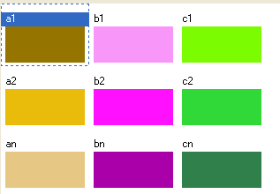

- SeqmeniT atributebis ruka Build_type rastruli rukidan Building_map_1998 (moniSneT sveti Build_type) da SexedeT Sedegad miRebul rukas.

axla Cven TiTqmis yvela aucilebeli monacemi gvaqvs wyaldidobis riskis SefasebisTvis: gvaqvs ruka Senobebis daxasiaTebiT (Build_type) da gvaqvs sami ruka wyaldidobis safrTxis sxvadasxva scenarisTvis (flood_010_cla, flood_050_cla da flood_100_cla). erTaderTi ram, rac gvaklia, aris imis msgavsi mowyvladobis mrudebi, rogorebic 5a savarjiSoSi SeqmeniT. am savarjiSos momdevno, saboloo nawilSi Cven SevqmniT 2-ganzomilebian cxrils, romelSic CavsvamT wyaldidobiT mowyvladobis mrudebs Senobis 9 tipidan TiToeulisTvis. am cxriliT miviRebT wyaldidobiT dazianebuli Senobebis wils.

- SeqmeniT axali 2-ganzomilebiani cxrili. daarqviT mas Flood_vuln; ZiriTadi domeni = Build_type, meoradi domeni = Depth. cvladis area: 0-dan 1-mde, xolo sizuste – 0.01.
- SeavseT cxrili ise, rogorc naCvenebia qvemoT mocemul suraTze.
- daxureT cxrili.

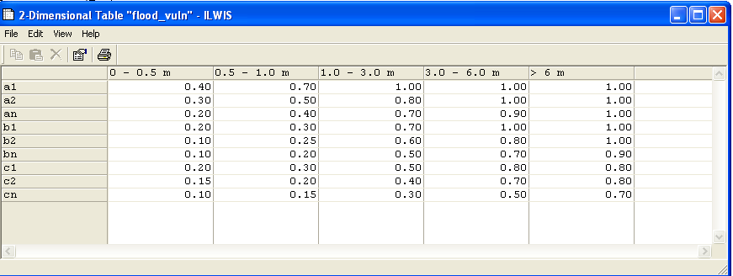

e space
SekiTxva 6F7:
2-ganzomilebiani cxrili warmoadgens 9 mowyvladobis mruds. daxateT es 9 mrudi qvemoT:

2-ganzomilebiani cxrili gamoiyeneba ori sxvadasxva rukidan miRebuli monacemebis integrirebisTvis Sedegad miRebul erT rukaSi. Cven siRrmis rukas Senobis tipis rukas SevadarebT da TiToeuli piqselisTvis Sesabamis saboloo mniSvnelobas vnaxavT cxrilSi. magaliTad, Tu Senobis tipia c2, xolo wyaldidobis siRrme – 1.0-3.0 m., maSin mowyvladobis mniSvnelobaa 0.40.

- 2-ganzomilebiani cxrilis gamosayeneblad ILWIS-is katalogis fanjris brZanebis striqonSi CawereT Semdegi debuleba :

build_damage_010:=flood_vuln[build_type,flood_010_cla]

SekiTxva 6F8:
ras warmoadgens Sedegad miRebuli ruka? rogor aris gamoxatuli riski am rukaze?

- gaimeoreT 2-ganzomilebiani cxrilis gamoyeneba wyaldidobis danarCeni ori scenarisTvis.

axla wyaldidobis riskis rukebi dasrulebulia. magram sasargebloa, rom SegveZlos am rukis, rogorc Building_map_1998 rukis atributi rukis warmodgena. amis gasakeTeblad jer gadaafareT Build_damage rukebs building_map_1998 rukasTan da Semdeg Sedegad miRebul cxrils SevaerTebT building_map_1998 cxrilTan.

- gadaafareT Building_map_1998 ruka Bbuild_damage_010 rukasTan da Sedegad miRebul cxrils daarqviT Build_1998_damage_010.
- gaxseniT cxrili Building_map_1998 da SeaerTeT is axal cxrilTan Build_1998_damage_010; aarCieT sveti Build_damage_010.
- gaiareT SeerTebis vizardis (join-wizard) yvela safexuri vizardis mier SemoTavazebuli defolt variantis (defaults), miRebiT magram bolo fanjaraSi agregaciis funqciad aarCieT “maximum” (zogierTi Senoba dazianebis or klass miekuTvneba da Cven varCevT uares SesaZleblobas).

- gaimeoreT es procedura wyaldidobis danarCeni ori scenarisTvis.

axla Building_map_1998 cxrils daemata Senobebis dazianeba wyaldidobis TiToeuli scenarisTvis. axla Tu gvecodineba TiToeuli Senobis Rirebuleba, SevZlebT wyaldidobis TiToeuli scenarisTvis sruli zaralis gamoTvlas da riskis mrudis agebas. amas momdevno savarjiSoSi gavakeTebT.

To be delivered:
sami Build_damage_xxx ruka (screen-dumps an eqsportirebuli bitmaps saxiT).

